🥂**Assemblies**

Assembly is basic unit of deployment in .NET and also container for all types. Assembly contains compiled types with their IL code, runtime resources, and information. When build an .exe in .NET, it will give you assembly .dll, and launcher .exe to the platfrom targeting.

# **❓What is Assembly?**

Assemblies is building block of .NET Framework applications, they are from the fundamental unit of deployment. Assembly is precompiled .NET Code that can run by CLR.

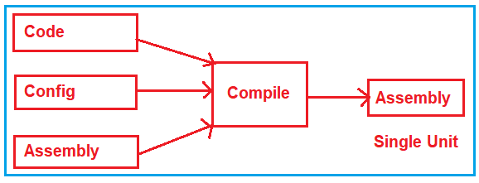

## **✌🏻Types of Assemblies**

* EXE ( Executable )
* DLL ( Dynamic Link Library)

### **🤷🏻‍♂️What is difference between EXE and DLL?**

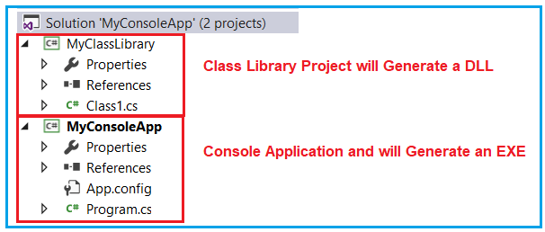

EXE is run its own address space or in its own memory space. If you double click it, the program will running.

While DLL, it cannot be run by itself. It needs consumer who is going invoke it. So, DLL will run in another memory space.